SMTP server configuration

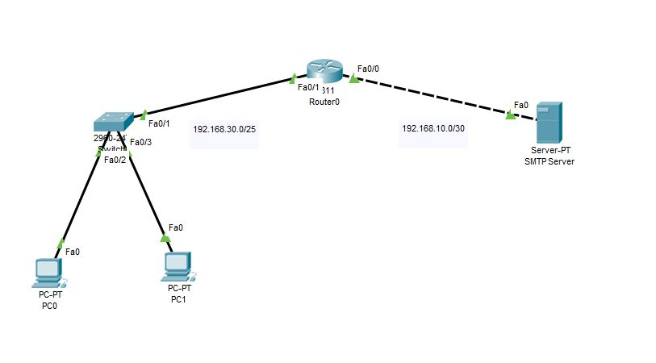

1. Interface

|  |  |  |  |
| --- | --- | --- | --- |
| Device | IP | subnet |  |
| **Pc0** | **192.168.30.1** | **255.255.255.128** |  |
| **Pc1** | **192.168.30.3** | **255.255.255.128** |  |
| **router** | **Fa 0/1 192.168.30.2**  **Fa 0/0 192.168.10.1** | **Fa 0/1 255.255.255.128**  **Fa 0/0 255.255.255.252** |  |
| **server** | **192.168.10.2** | **255.255.255.252** |  |

1. Router config:

I have put the host name as Office. The port configuration is as the above table, enabled a **password** in the **admin mode**. I have done **DHCP** for the network **192.168.30.0/25.**

Command: **Office#show running-config**

1. Server config:

I have set the IP static. I have enabled two user mail account by going to the services.

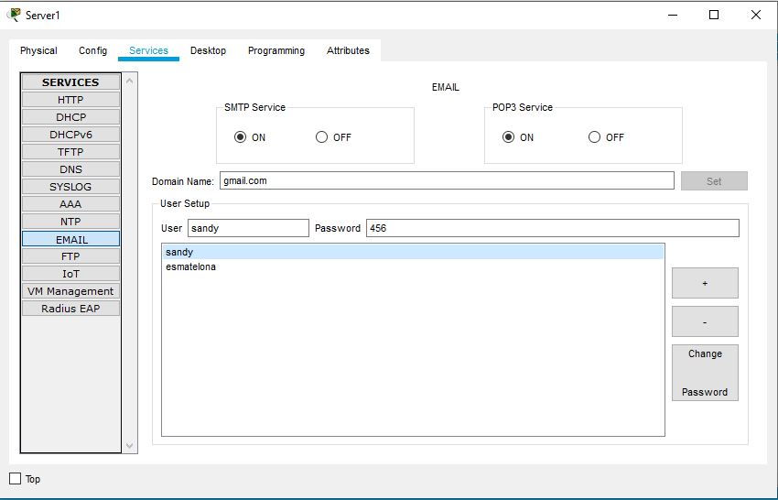

1. Host email config

Now setting up the email configuration is done in each host as below

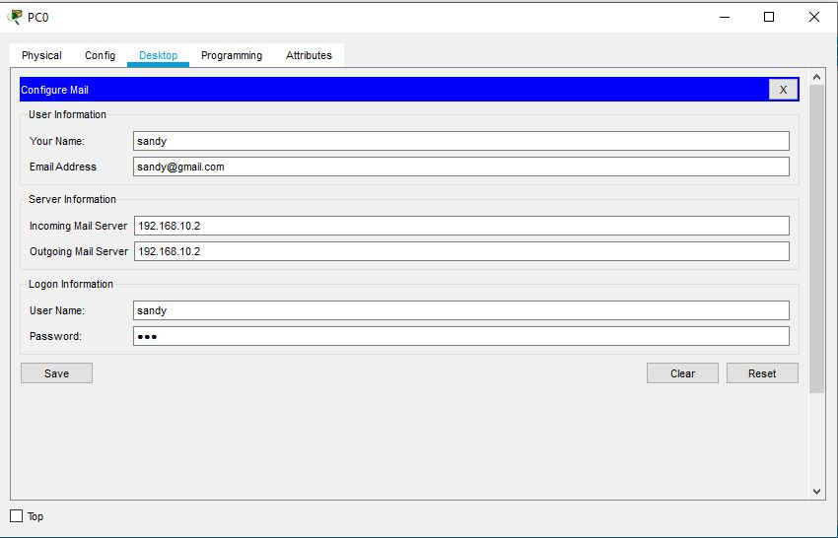

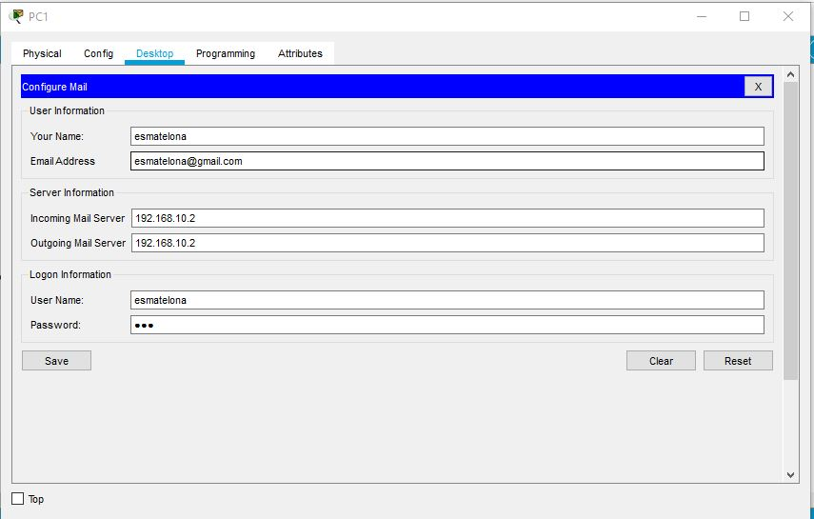

1. Sending & Receiving Email:

Now composing a test email from **pc1** to **pc0**

